**SARJANA MUDA SAINS KOMPUTER DENGAN INFORMATIK MARITIM (KEPUJIAN)  
  
 SESI 2024/2025  
 CSF 3133 – WEB BASED INTERFACE DESIGN**

**LAB 8  
  
 LECTURE NAME**

**Ts. DR. ILY AMALINA AHMAD SABRI**

|  |  |
| --- | --- |
| **NAME** | **NUM MATRICS** |
| HAZRIHALIMI IZHAR BIN HARUN | S70270 |

**Lab 8 BOOTSTRAP**

Objectives:

1. You are able build responsive designs with Bootstrap
2. You understand how the HTML, CSS and JavaScript components of Bootstrap work

**What is Bootstrap?**

* Bootstrap is a free front-end framework for faster and easier web development
* Bootstrap includes HTML and CSS based design templates for typography, forms, buttons, tables, navigation, modals, image carousels and many other, as well as optional JavaScript plugins
* Bootstrap also gives you the ability to easily create responsive designs

**What is Responsive Web Design?**

* Responsive web design is about creating web sites which automatically adjust themselves to look good on all devices, from small phones to large desktops.

**Advantages of Bootstrap:**

* Easy to use: Anybody with just basic knowledge of HTML and CSS can start using Bootstrap
* Responsive features: Bootstrap's responsive CSS adjusts to phones, tablets, and desktops
* Mobile-first approach: In Bootstrap 3, mobile-first styles are part of the core framework
* Browser compatibility: Bootstrap is compatible with all modern browsers (Chrome, Firefox, Internet Explorer, Edge, Safari, and Opera)

**So, why choose Bootstrap?**

* Quickly design and customize responsive mobile-first sites with Bootstrap, the world’s most popular front-end open source toolkit, featuring Sass variables and mixins, responsive grid system, extensive prebuilt components, and powerful JavaScript plugins.

**Where to Get Bootstrap?**

There are two ways to start using Bootstrap on your own web site.

You can either:

* Download Bootstrap from getbootstrap.com, or
* Include Bootstrap from a CDN

**Downloading Bootstrap**

If you want to download and host Bootstrap yourself, go to [www.getbootstrap.com](http://www.getbootstrap.com), and follow the instructions there.

**Bootstrap CDN**

If you don't want to download and host Bootstrap yourself, you can include it from a CDN (Content Delivery Network).

MaxCDN provides CDN support for Bootstrap's CSS and JavaScript. You just call them inside the <head> tag

<!-- Latest compiled and minified CSS -->

<link rel="stylesheet" href="https://maxcdn.bootstrapcdn.com/bootstrap/3.4.1/css/bootstrap.min.css">

<!-- jQuery library -->

<script src="https://ajax.googleapis.com/ajax/libs/jquery/3.5.1/jquery.min.js"></script>

<!-- Latest compiled JavaScript -->

<script src="https://maxcdn.bootstrapcdn.com/bootstrap/3.4.1/js/bootstrap.min.js"></script>

**TASK 1**

* **Activity 1**

**Create First Web Page with Bootstrap**

1. Add the HTML5 doctype

Bootstrap uses HTML elements and CSS properties that require the HTML5 doctype.

Always include the HTML5 doctype at the beginning of the page, along with the lang attribute and the correct character set:

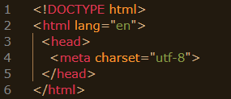

2.  Bootstrap 4 is mobile-first

Bootstrap 4 is designed to be responsive to mobile devices. Mobile-first styles are part of the core framework. To ensure proper rendering and touch zooming, add the following <meta> tag inside the <head> element:



The width=device-width part sets the width of the page to follow the screen-width of the device (which will vary depending on the device).

The initial-scale=1 part sets the initial zoom level when the page is first loaded by the browser.

1. Add link to CDN files

If you do not want to download and host Bootstrap 4 yourself, you can include it from a CDN (Content Delivery Network).

MaxCDN provides CDN support for Bootstrap's CSS and JavaScript. You must also include jQuery: (put them inside tag <head>

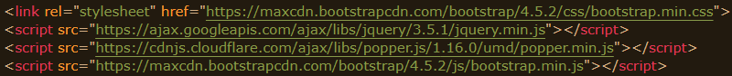

1. Example of your First bootstrap page

The following example shows the code for a basic Bootstrap 4 page (with a responsive fixed width container). Put together all main components in number 1,2,3 above into one webpage :

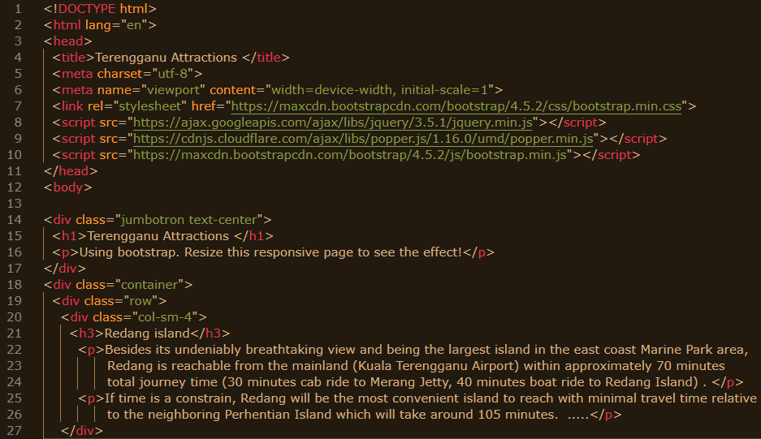

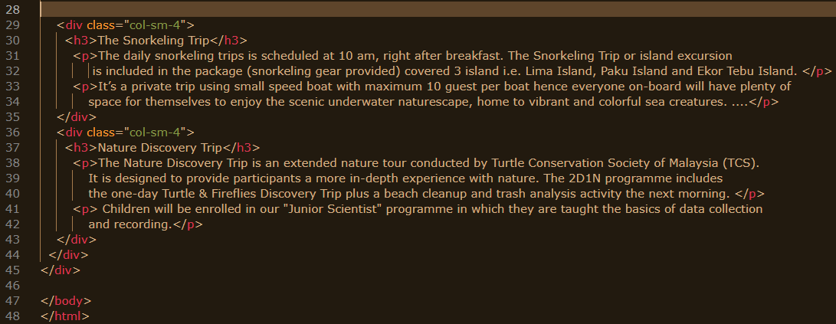

Text in 1st column :

<p>Besides its undeniably breathtaking view and being the largest island in the east coast Marine Park area, Redang is reachable from the mainland (Kuala Terengganu Airport) within approximately 70 minutes total journey time (30 minutes cab ride to Merang Jetty, 40 minutes boat ride to Redang Island) . </p>

<p>If time is a constrain, Redang will be the most convenient island to reach with minimal travel time relative  to the neighboring Perhentian Island which will take around 105 minutes.  .....</p>

Text in 2nd column :

<p>The daily snorkeling trips is scheduled at 10 am, right after breakfast. The Snorkeling Trip or island excursion is included in the package (snorkeling gear provided) covered 3 island i.e. Lima Island, Paku Island and Ekor Tebu Island. </p>

<p>It’s a private trip using small speed boat with maximum 10 guest per boat hence everyone on-board will have plenty of  space for themselves to enjoy the scenic underwater naturescape, home to vibrant and colorful sea creatures. ....</p>

Text in 3rd column :

<p>The Nature Discovery Trip is an extended nature tour conducted by Turtle Conservation Society of Malaysia (TCS).  It is designed to provide participants a more in-depth experience with nature. The 2D1N programme includes the one-day Turtle & Fireflies Discovery Trip plus a beach cleanup and trash analysis activity the next morning. </p>

<p> Children will be enrolled in our "Junior Scientist" programme in which they are taught the basics of data collection and recording.</p>

**Conclusion and Result:**

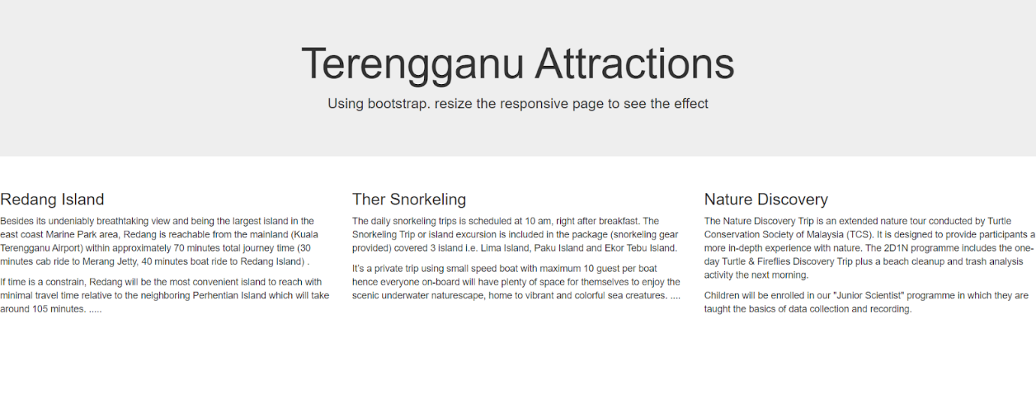

* **Activity 2**

**Responsive Image**

Images come in all sizes. So do screens. Responsive images automatically adjust to fit the size of the screen.

Create responsive images by adding an .img-fluid class to the <img> tag. The image will then scale nicely to the parent element.

The .img-fluid class applies max-width: 100%; and height: auto; to the image

Try these codes:

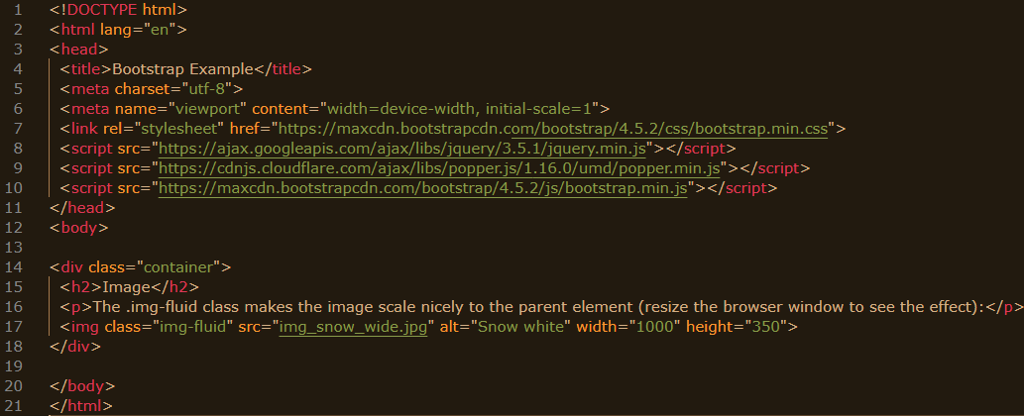

Try to resize the window of your browser.

**Conclusion and Result:**

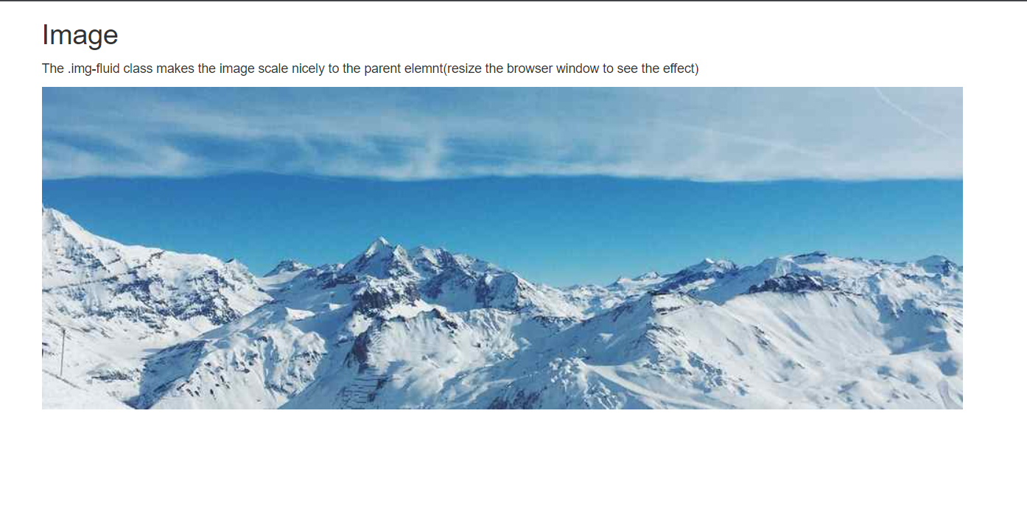

* **Activity 3**

**Bootstrap Text/Typography**

Bootstrap uses a default font-size of 16px, and its line-height is 1.5.

The default font-family is "Helvetica Neue", Helvetica, Arial, sans-serif.

In addition, all <p> elements have margin-top: 0 and margin-bottom: 1rem (16px by default).

<h1> - <h6>

Bootstrap styles HTML headings (<h1> to <h6>) with a bolder font-weight and an increased font-size.

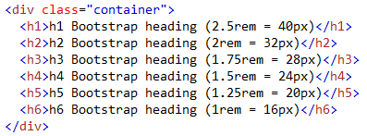

Display Headings

Display headings are used to stand out more than normal headings (larger font-size and lighter font-weight), and there are four classes to choose from: .display-1, .display-2, .display-3, .display-4

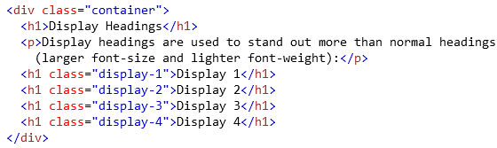

<blockquote>

Add the .blockquote class to a <blockquote> when quoting blocks of content from another source:

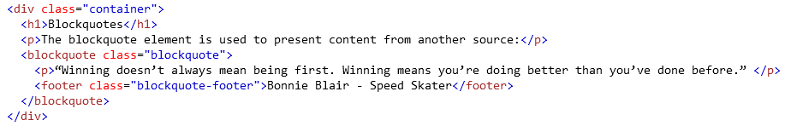

Text of quote : “Winning doesn’t always mean being first. Winning means you’re doing better than you’ve done before.”

DEFINITION LIST   <dl>

The dl element indicates a description list.

Bootstrap will style the HTML <dl> element in the following way:

Example:

**Coffee**

     - black hot drink

**Milk**

     - white cold drink

Html code :

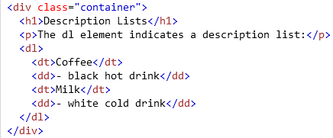

Try to put all previous codes in one page, and then open it on your browser.

**Conclusion and Result:**

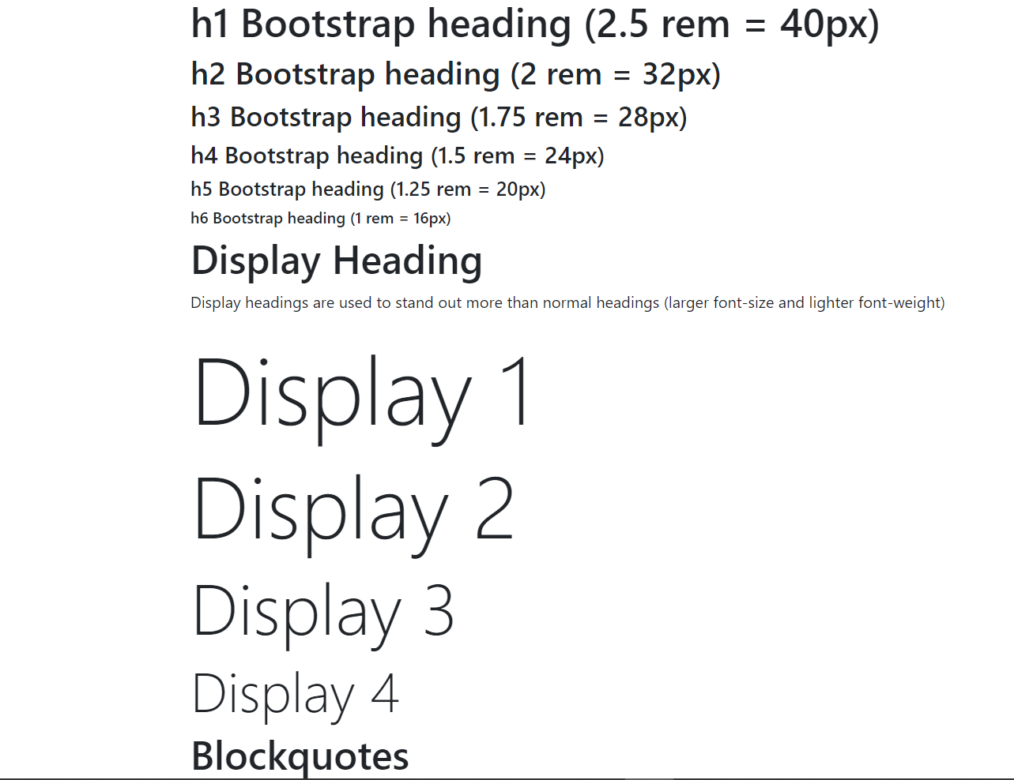

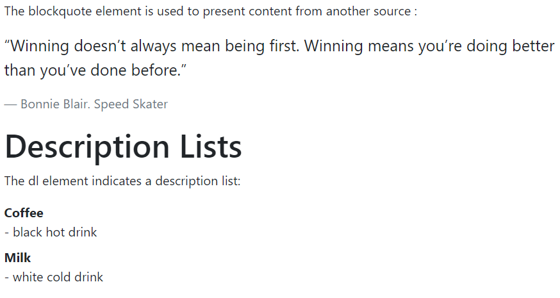

* **Activity 4**

**Bootstrap CSS Forms**

Individual form controls automatically receive some global styling with Bootstrap.

All textual <input>, <textarea>, and <select> elements with class="form-control" are set to width: 100%; by default.

Standard rules for all three form layouts:

* Wrap labels and form controls in <div class="form-group"> (needed for optimum spacing)
* Add class .form-control to all textual <input>, <textarea>, and <select> elements

The following example creates a simple Bootstrap form with two input fields, one checkbox, and a submit button:

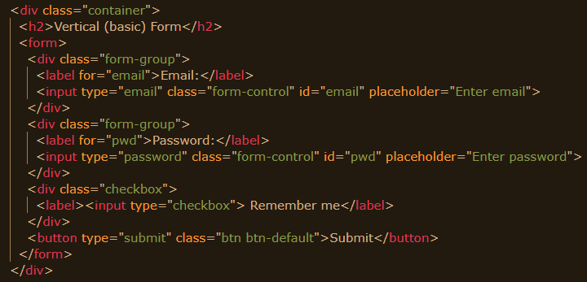

Try to put the codes in a webpage using bootstrap, and then open it on your browser.

**Conclusion and Result**

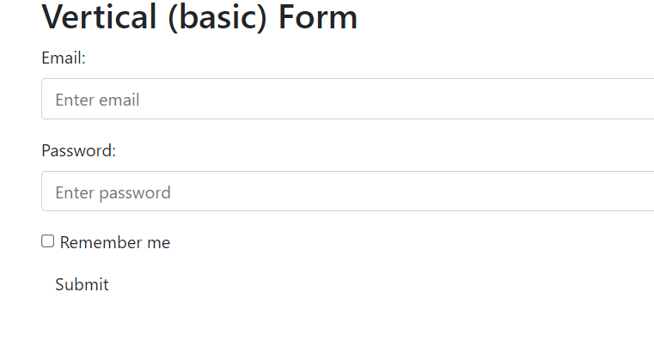

**TASK 2**

**Using Bootstrap theme**

What is a Bootstrap theme? A Bootstrap theme is a package containing CSS, HTML, and JavaScript code used for styling. Bootstrap themes also feature various UI components and page layouts that can be employed to create websites.

* **Activity 5**

**Using theme “Simply Me”**

This activity will show you how to build a Bootstrap theme from scratch.

We will start with a simple HTML page, and then add more and more components, until we have a fully functional, personal and responsive website.

You are free to modify, save, share, use or do whatever you want with it.

**Step 1.** HTML Start Page

We will start with the following HTML page:

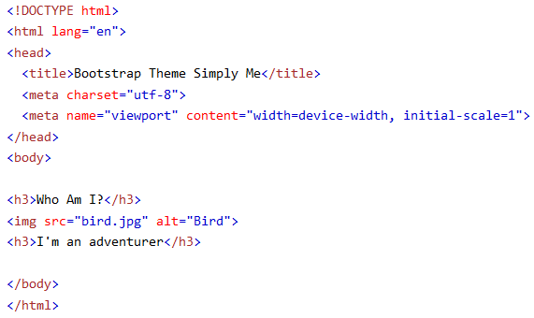

**Step 2.** Add Bootstrap CDN and a link to jQuery and put HTML elements inside a container:

 <link rel="stylesheet" href="https://maxcdn.bootstrapcdn.com/bootstrap/3.4.1/css/bootstrap.min.css">

 <script src="https://ajax.googleapis.com/ajax/libs/jquery/3.5.1/jquery.min.js"></script>

 <script src="https://maxcdn.bootstrapcdn.com/bootstrap/3.4.1/js/bootstrap.min.js"></script>

inside <head>:

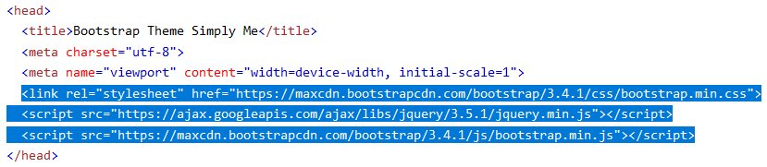

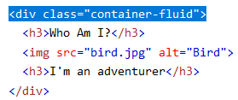

**Step 3.** Add Background Color and Center Text

1. Add a custom class (.bg-1) to the container to add a background color.

2. Add the .text-center class to center the text inside the container:

<head>  
<style>  
  .bg-1 {

    background-color: #1abc9c;  /* Green */

    color: #ffffff;

  }

</style>

</head>  
  
<body>  
  <div class="container-fluid bg-1 text-center">

    <h3>Who Am I?</h3>

     <img src="bird.jpg" alt="Bird">

     <h3>I'm an adventurer</h3>

  </div>

</body>

**Step 4.** Circle Image

Shape the image to a circle with the .img-circle class:

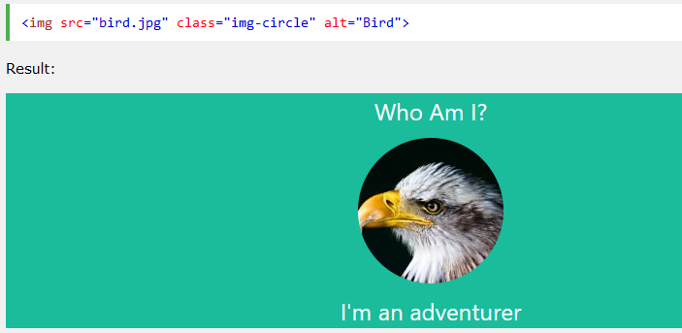

**Step 4.** More Content

Add more content and put it inside new containers:

  <head>  
  <style>  
  .bg-1 {   
    background-color: #1abc9c; /* Green */  
    color: #ffffff;  
  }  
  .bg-2 {   
    background-color: #474e5d; /* Dark Blue */  
    color: #ffffff;  
  }  
  .bg-3 {   
    background-color: #ffffff; /* White */  
    color: #555555;  
  }  
  </style>  
</head>  
  
<body>  
  
<div class="container-fluid bg-1 text-center">  
  <h3>Who Am I ?</h3>  
  <img src="bird.jpg" class="img-circle" alt="Bird">  
  <h3>I'm an adventurer</h3>  
</div>  
  
<div class="container-fluid bg-2 text-center">  
  <h3>What Am I?</h3>  
  <p>copy text : Lorem ipsum…..</p>  
</div>  
  
<div class="container-fluid bg-3 text-center">  
  <h3>Where To Find Me?</h3>  
  <p>copy text : Lorem ipsum…..</p>  
</div>

</body>

**Step 5.** Add Padding

Lets make the containers look good by adding some padding

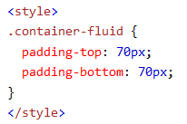

**Step 6.** Add a Button

Add a button to the mid container:

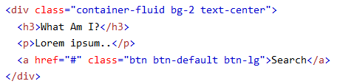

**Step 7.** Add an Icon

Add a Search icon on the "Search" button

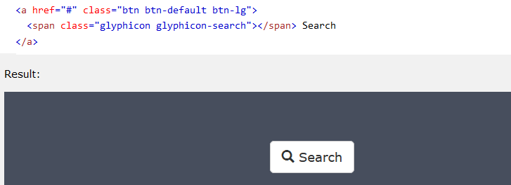

**Step 8.** Modify The Third Container (Add Grid)

Add three columns of equal width inside the third container (.col-sm-4):

<div class="container-fluid bg-3 text-center">   
  <h3>Where To Find Me? </h3>  
  <div class="row">  
    <div class="col-sm-4">  
      <p>copy text : Lorem ipsum. ….. </p>  
      <img src="birds1.jpg" alt="Image">  
    </div>  
    <div class="col-sm-4">  
       <p>copy text : Lorem ipsum. ….. </p>  
      <img src="birds2.jpg" alt="Image">  
    </div>  
    <div class="col-sm-4">   
       <p>copy text : Lorem ipsum. ….. </p>  
      <img src="birds3.jpg" alt="Image">  
    </div>  
  </div>  
</div>

**Step 9.** Make The Images Responsive

Add the .img-responsive class to all images.

Add display:inline to the first image to force it to be centered (the .img-responsive class adds display:block to the image, which makes it jump to the left of the screen).

If you want the image to span the entire width of the screen when it starts to stack, add width:100% to the image.

When opening the example, remember to resize the screen to see the responsive effect:

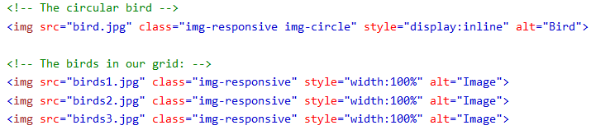

**Step 10.** Add a Navbar

Add a standard navigation bar at the top of the page with and make it collapsible on smaller screens:

<nav class="navbar navbar-default">  
  <div class="container">  
    <div class="navbar-header">  
      <button type="button" class="navbar-toggle" data-toggle="collapse" data-target="#myNavbar">  
        <span class="icon-bar"></span>  
        <span class="icon-bar"></span>  
        <span class="icon-bar"></span>   
      </button>  
      <a class="navbar-brand" href="#">Me</a>  
    </div>  
    <div class="collapse navbar-collapse" id="myNavbar">  
      <ul class="nav navbar-nav navbar-right">  
        <li><a href="#">WHO</a></li>  
        <li><a href="#">WHAT</a></li>  
        <li><a href="#">WHERE</a></li>  
      </ul>  
    </div>  
  </div>  
</nav>

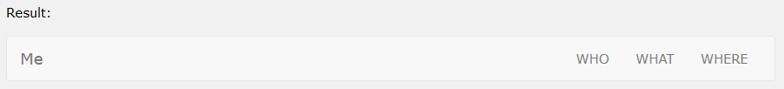

**Step 10.** Style the Navbar

Use CSS to customize the navigation bar:

  .navbar {

   padding-top: 15px;

   padding-bottom: 15px;

  border: 0;

  border-radius: 0;

  margin-bottom: 0;

   font-size: 12px;

  letter-spacing: 5px;

     }  
   .navbar-nav li a:hover {

   color: #1abc9c **!important**;

     }

**Step 11.** Add a Footer

Add a footer and use CSS to style it

<style>

.bg-4 {   
   background-color: #2f2f2f;  
  color: #ffffff;

    }  
</style>

<footer class="container-fluid bg-4 text-center">  
      <p>Bootstrap Theme “ Simply Me “ </p>   
</footer>

**Step 12.** Final Touch

Personalize your Theme by adding a font that you like. We have used "Montserrat" from Google's Font Library.

Link to the font in the <head> section:

  <link href="https://fonts.googleapis.com/css?family=Montserrat" rel="stylesheet">

Then you can use it in the page:

body {

  font: 20px "Montserrat", sans-serif;

   line-height: 1.8;

  color: #f5f6f7;

}

p {font-size: 16px;}

**Text: (you do not need to use all these texts)**

The standard Lorem Ipsum passage, used since the 1500s

"Lorem ipsum dolor sit amet, consectetur adipiscing elit, sed do eiusmod tempor incididunt ut labore et dolore magna aliqua. Ut enim ad minim veniam, quis nostrud exercitation ullamco laboris nisi ut aliquip ex ea commodo consequat. Duis aute irure dolor in reprehenderit in voluptate velit esse cillum dolore eu fugiat nulla pariatur. Excepteur sint occaecat cupidatat non proident, sunt in culpa qui officia deserunt mollit anim id est laborum."

 Section 1.10.32 of "de Finibus Bonorum et Malorum", written by Cicero in 45 BC

"Sed ut perspiciatis unde omnis iste natus error sit voluptatem accusantium doloremque laudantium, totam rem aperiam, eaque ipsa quae ab illo inventore veritatis et quasi architecto beatae vitae dicta sunt explicabo. Nemo enim ipsam voluptatem quia voluptas sit aspernatur aut odit aut fugit, sed quia consequuntur magni dolores eos qui ratione voluptatem sequi nesciunt. Neque porro quisquam est, qui dolorem ipsum quia dolor sit amet, consectetur, adipisci velit, sed quia non numquam eius modi tempora incidunt ut labore et dolore magnam aliquam quaerat voluptatem. Ut enim ad minima veniam, quis nostrum exercitationem ullam corporis suscipit laboriosam, nisi ut aliquid ex ea commodi consequatur? Quis autem vel eum iure reprehenderit qui in ea voluptate velit esse quam nihil molestiae consequatur, vel illum qui dolorem eum fugiat quo voluptas nulla pariatur?"

* **Activity 6**

**Using theme “My Company”**

This activity will show you how to build a Bootstrap theme from scratch.

We will start with a simple HTML page, and then add more and more components, until we have a fully functional, personal and responsive website.

You are free to modify, save, share, use or do whatever you want with it.

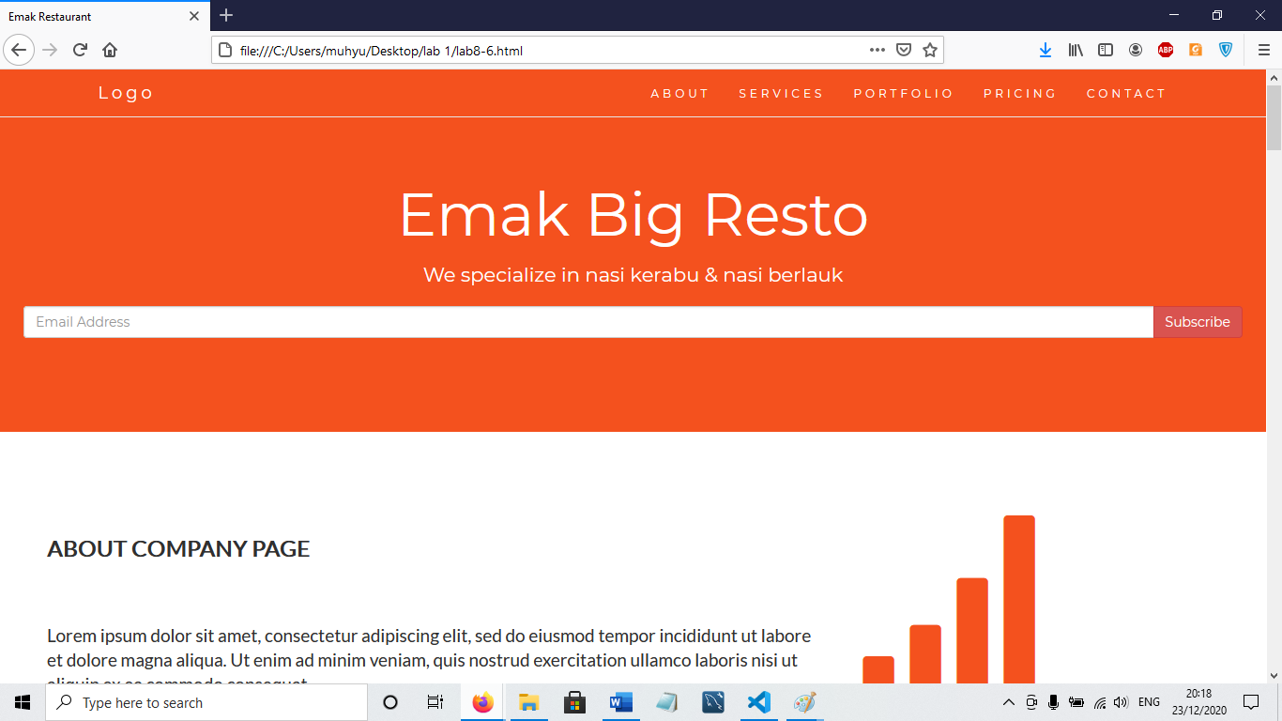

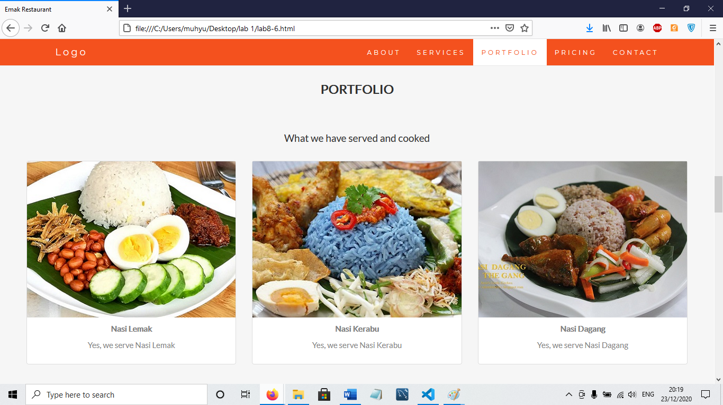

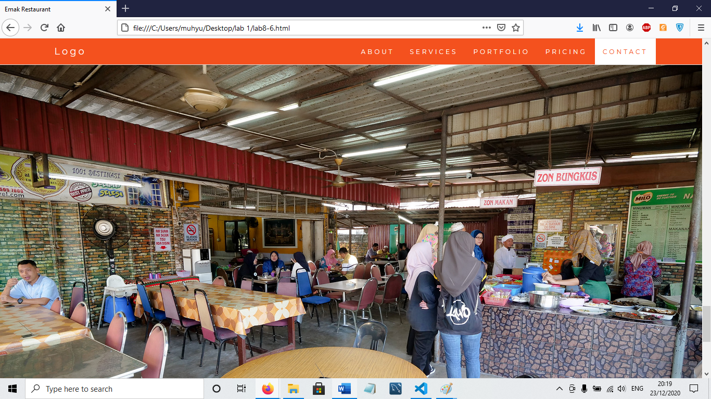

**Lab Exercise**

|  |
| --- |
| <!DOCTYPE html>  <html lang="en">  <head>    <title>FutureTech Solutions</title>    <meta charset="utf-8">    <meta name="viewport" content="width=device-width, initial-scale=1">    <link rel="stylesheet" href="https://maxcdn.bootstrapcdn.com/bootstrap/3.4.1/css/bootstrap.min.css">    <link href="https://fonts.googleapis.com/css?family=Montserrat" rel="stylesheet" type="text/css">    <link href="https://fonts.googleapis.com/css?family=Lato" rel="stylesheet" type="text/css">    <script src="https://ajax.googleapis.com/ajax/libs/jquery/3.5.1/jquery.min.js"></script>    <script src="https://maxcdn.bootstrapcdn.com/bootstrap/3.4.1/js/bootstrap.min.js"></script>    <style>      body {        font: 400 15px Lato, sans-serif;        line-height: 1.8;        color: #000000;      }      h2 {        font-size: 24px;        text-transform: uppercase;        color: #000000;        font-weight: 600;        margin-bottom: 30px;      }      h4 {        font-size: 19px;        line-height: 1.375em;        color: #000000;        font-weight: 400;        margin-bottom: 30px;      }      .jumbotron {        background-color: #0077B6;        color: #fff;        padding: 100px 25px;        font-family: Montserrat, sans-serif;      }      .container-fluid {        padding: 60px 50px;      }      .bg-grey {        background-color: #f6f6f6;      }      .logo {        color: #0077B6;        font-size: 200px;      }      .thumbnail {        padding: 0 0 15px 0;        border: none;        border-radius: 0;      }      .thumbnail img {        width: 100%;        height: 100%;        margin-bottom: 10px;      }      .navbar {        margin-bottom: 0;        background-color: #0077B6;        z-index: 9999;        border: 0;        font-size: 12px !important;        line-height: 1.42857143 !important;        letter-spacing: 4px;        border-radius: 0;        font-family: Montserrat, sans-serif;      }      .navbar li a, .navbar .navbar-brand {        color: #fff !important;      }      .navbar-nav li a:hover, .navbar-nav li.active a {        color: #0077B6 !important;        background-color: #fff !important;      }      .navbar-default .navbar-toggle {        border-color: transparent;        color: #fff !important;      }      footer {        background-color: #0077B6;        color: #fff;        padding: 32px;      }      footer a {        color: #fff;      }      footer a:hover {        color: #777;        text-decoration: none;      }    </style>  </head>  <body id="myPage" data-spy="scroll" data-target=".navbar" data-offset="60">    <nav class="navbar navbar-default navbar-fixed-top">      <div class="container">        <div class="navbar-header">          <button type="button" class="navbar-toggle" data-toggle="collapse" data-target="#myNavbar">            <span class="icon-bar"></span>            <span class="icon-bar"></span>            <span class="icon-bar"></span>          </button>          <a class="navbar-brand" href="#home">FutureTech</a> <!-- Added link to home section -->        </div>        <div class="collapse navbar-collapse" id="myNavbar">          <ul class="nav navbar-nav navbar-right">            <li><a href="#home">Home</a></li> <!-- Added Home link here -->            <li><a href="#about">ABOUT</a></li>            <li><a href="#services">SERVICES</a></li>            <li><a href="#contact">CONTACT</a></li>          </ul>        </div>      </div>    </nav>    <div class="jumbotron text-center">    <h1>FutureTech Solutions</h1>    <p>Your Partner in IT Excellence</p>  </div>  <div id="about" class="container-fluid">    <div class="row">      <div class="col-sm-8">        <h2>About Us</h2><br>        <h4>"FutureTech Solutions is an innovative web design and development agency committed to crafting cutting-edge digital experiences. Our goal is to help businesses build a strong online presence and thrive in the ever-evolving digital landscape.".</h4><br>        <p><strong>Vision:</strong> To be the leading IT consulting firm recognized for excellence and innovation.</p>      </div>      <div class="col-sm-4">        <span class="glyphicon glyphicon-globe logo"></span>      </div>    </div>  </div>  <div id="services" class="container-fluid text-center bg-grey">    <h2>Services</h2>    <h4>What we offer</h4>    <div class="row">      <div class="col-sm-4">        <span class="glyphicon glyphicon-cloud logo-small"></span>        <h4>Cloud Solutions</h4>        <p>Seamless cloud integration for modern businesses.</p>      </div>      <div class="col-sm-4">        <span class="glyphicon glyphicon-cog logo-small"></span>        <h4>IT Consulting</h4>        <p>Expert guidance for your digital transformation.</p>      </div>      <div class="col-sm-4">        <span class="glyphicon glyphicon-lock logo-small"></span>        <h4>Cybersecurity</h4>        <p>Protecting your data with cutting-edge solutions.</p>      </div>    </div>  </div>  <div id="contact" class="container-fluid">    <h2 class="text-center">Contact</h2>    <div class="row">      <div class="col-sm-5">        <p>Contact us and we'll get back to you within 24 hours.</p>        <p><span class="glyphicon glyphicon-map-marker"></span> Kuala Terengganu, Terengganu</p>        <p><span class="glyphicon glyphicon-phone"></span> +60 0104197947</p>        <p><span class="glyphicon glyphicon-envelope"></span> Hazri@futuretech.com</p>      </div>      <div class="col-sm-7 slideanim">        <form>          <div class="row">            <div class="col-sm-6 form-group">              <input class="form-control" id="name" name="name" placeholder="Name" type="text" required>            </div>            <div class="col-sm-6 form-group">              <input class="form-control" id="email" name="email" placeholder="Email" type="email" required>            </div>          </div>          <textarea class="form-control" id="comments" name="comments" placeholder="Message" rows="5"></textarea><br>          <div class="row">            <div class="col-sm-12 form-group">              <button class="btn btn-default pull-right" type="submit">Send</button>            </div>          </div>        </form>      </div>    </div>  </div>  <footer class="text-center">    <a href="#myPage" title="To Top">      <span class="glyphicon glyphicon-chevron-up"></span>    </a>    <p>Hazri FutureTech Solutions &copy; 2025</p>    </a> |

